SIDDAGANGA INSTITUTE OF TECHNOLOGY,
TUMKUR

Data Structures and Applications Activity
(Activity Based Learning Report)
On

Micro Project - Snake and Ladder game
Submitted in the partial fulfilment of the requirements for III Semester
Data Structures and Applications (S3CCS01)

Submitted by

MANAN AGARWAL - 1SI23CS104
PREET KUMAR KESRI – 1SI23CS140
PRATIKSHA TS – 1SI23CS139



Siddaganga Institute of Technology, Tumkur
(An Autonomous Institute, Affiliated to Visvesvaraya Technological University Belagavi, Approved by AICTE, New Delhi, Accredited by NAAC and ISO 9001:2015 certified)
B.H. road, Tumkur 572103, Karnataka, India
AY: 2023-24
SIDDAGANGA INSTITUTE OF TECHNOLOGY, TUMAKURU-3
(An Autonomous Institution, Affiliated to VTU, Belagavi & Recognized by AICTE, New Delhi)
DEPARTMENT OF COMPUTER SCIENCE & ENGINEERING



Name of student | USN | Marks
Preet Kumar Keshri | 1SI23CS140
Manan Agarwal | 1SI23CS104
Prathiksha Ts | 1SI23CS139

Signature of In charge Faculty

ABSTRACT

This project focuses on developing a Snakes and Ladders game using the C programming language. The objective of the game is to provide an engaging and interactive experience to the players. The game will involve any number of players who will compete amongst themselves to reach the finish line. The game will also feature game elements such as ladders, snakes, and difficulty levels that will add to the challenge and excitement of the game. The project will involve developing the game logic, designing the game interface and implementing simple graphics. The game logic will include defining the rules of the game, setting up the game board, and managing player movements.

The game interface will be designed to provide a user-friendly experience and allow players to interact with the game elements. The graphics will be created using simple shapes to enhance the visual appeal of the game. The game will be developed using the C programming language and will use a console-based interface. This project will provide an opportunity to learn and apply programming concepts and techniques in a practical way while developing an exciting and fun game. Overall, the project will help students to develop skills in programming, game development, and problem-solving

Data Structures used:
• Singly Linked List with header node
• Arrays

ANALYSIS

Snakes and Ladders is a classic board game that has been enjoyed by people of all ages for generations. The game involves rolling a dice to move across a board, which is filled with snakes and ladders that can either advance or set back the players. With the increasing popularity of video games, it is no surprise that Snakes and Ladders has made its way into the digital world. In this project, we will be developing a Snakes and Ladders game using the C programming language.

The game will be developed using the C programming language, which is a popular and widely used language in the field of programming. The project will require developing the game logic, designing the game interface, implementing graphics, and creating sound effects. The game logic will include defining the rules of the game, setting up the game board, and managing player movements. The game interface will be designed to provide a user-friendly experience and allow players to interact with the game elements. Graphics will be created using simple shapes to provide an immersive experience to the players.

When a user selects to launch our game application, he encounters our main screen. Then based upon the user’s choice operations will be performed…...!

• Select difficulty level
1. Easy
2. Medium
3. Hard

• Select number of players

• Rolling the dice

Instructions:

➢ Each player starts from step 0.

➢ Turns will be provided to each player to roll the dice.

➢ If any player lands at the bottom of a ladder, he/she will be moved up to the top of the ladder.

➢ If any player lands on the head of a snakes, he/she will be moved down to the bottom of the ladder.

➢ The first player to reach 100 is the winner.

Flowchart Description Of the code

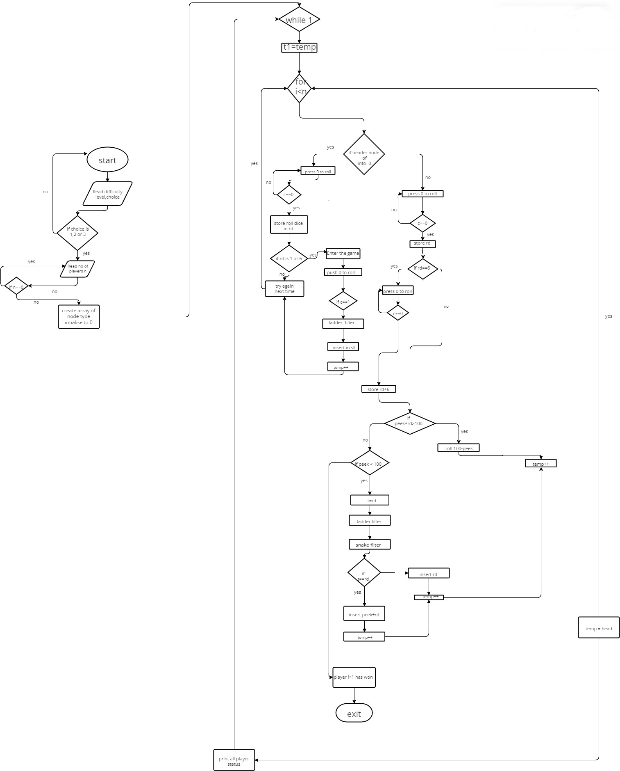
IMPLEMENTATION

#include <stdio.h>
#include <stdlib.h>
#include <math.h>
#include <time.h>

typedef struct node
{
int info;
struct node *next;
} NODE;

void ins_last(NODE *head, int data)
{
NODE *newnode, *temp;
newnode = (NODE *)malloc(sizeof(NODE));
newnode->info = data;
newnode->next = NULL;
temp = head;
while (temp->next != NULL)
temp = temp->next;
temp->next = newnode;
head->info++;
}

int peek(NODE *head)
{
NODE *temp = head;
while (temp->next != NULL)
{
temp = temp->next;
}
return (temp->info);
}

int ladder(int n)
{
switch (n)
{
case 4:
printf("Congrats!! You encountered a ladder. You have now climbed to 14\n");
return 14;
default:
return n;
}
}
int ladder2(int p, int n)
{
switch (n + p)
{
case 4:
printf("Congrats!! You encountered a ladder. You have now climbed to 14\n");
return 14;
case 8:
printf("Congrats!! You encountered a ladder. You have now climbed to 30\n");
return 30;
case 21:
printf("Congrats!! You encountered a ladder. You have now climbed to 42\n");
return 42;
case 28:
printf("Congrats!! You encountered a ladder. You have now climbed to 76\n");
return 76;
case 32:
printf("Congrats!! You encountered a ladder. You have now climbed to 49\n");
return 49;
case 50:
printf("Congrats!! You encountered a ladder. You have now climbed to 67\n");
return 67;
case 71:
printf("Congrats!! You encountered a ladder. You have now climbed to 92\n");
return 92;
case 84:
printf("Congrats!! You encountered a ladder. You have now climbed to 99\n");
return 99;
default:
return n;
}
}
int snake(int p, int n, int c)
{
if (c == 1)
{
switch (n + p)
{
case 35:
printf("Oh no!! You encountered a snake. You have now fallen down to 10\n");
return 10;
case 39:
printf("Oh no!! You encountered a snake. You have now fallen down to 6\n");
return 6;
case 62:
printf("Oh no!! You encountered a snake. You have now fallen down to 18\n");
return 18;
case 48:
printf("Oh no!! You encountered a snake. You have now fallen down to 26\n");
return 26;
case 88:
printf("Oh no!! You encountered a snake. You have now fallen down to 24\n");
return 24;
case 95:
printf("Oh no!! You encountered a snake. You have now fallen down to 56\n");
return 56;
case 97:
printf("Oh no!! You encountered a snake. You have now fallen down to 78\n");
return 78;
default:
return n;
}
}
else if (c == 2)
{
switch (n + p)
{
case 35:
printf("Oh no!! You encountered a snake. You have now fallen down to 10\n");
return 10;
case 39:
printf("Oh no!! You encountered a snake. You have now fallen down to 6\n");
return 6;
case 62:
printf("Oh no!! You encountered a snake. You have now fallen down to 18\n");
return 18;
case 48:
printf("Oh no!! You encountered a snake. You have now fallen down to 26\n");
return 26;
case 88:
printf("Oh no!! You encountered a snake. You have now fallen down to 24\n");
return 24;
case 95:
printf("Oh no!! You encountered a snake. You have now fallen down to 56\n");
return 56;
case 97:
printf("Oh no!! You encountered a snake. You have now fallen down to 78\n");
return 78;
case 29:
printf("Oh no!! You encountered a snake. You have now fallen down to 7\n");
return 7;
case 12:
printf("Oh no!! You encountered a snake. You have now fallen down to 5\n");
return 5;
case 43:
printf("Oh no!! You encountered a snake. You have now fallen down to 20\n");
return 20;
case 56:
printf("Oh no!! You encountered a snake. You have now fallen down to 22\n");
return 22;
default:
return n;
}
}
else if (c == 3)
{
switch (n + p)
{
case 35:
printf("Oh no!! You encountered a snake. You have now fallen down to 10\n");
return 10;
case 39:
printf("Oh no!! You encountered a snake. You have now fallen down to 6\n");
return 6;
case 62:
printf("Oh no!! You encountered a snake. You have now fallen down to 18\n");
return 18;
case 48:
printf("Oh no!! You encountered a snake. You have now fallen down to 26\n");
return 26;
case 88:
printf("Oh no!! You encountered a snake. You have now fallen down to 24\n");
return 24;
case 95:
printf("Oh no!! You encountered a snake. You have now fallen down to 56\n");
return 56;
case 97:
printf("Oh no!! You encountered a snake. You have now fallen down to 78\n");
return 78;
case 29:
printf("Oh no!! You encountered a snake. You have now fallen down to 7\n");
return 7;
case 12:
printf("Oh no!! You encountered a snake. You have now fallen down to 5\n");
return 5;
case 43:
printf("Oh no!! You encountered a snake. You have now fallen down to 20\n");
return 20;
case 56:
printf("Oh no!! You encountered a snake. You have now fallen down to 22\n");
return 22;
case 57:
printf("Oh no!! You encountered a snake. You have now fallen down to 19\n");
return 19;
case 77:
printf("Oh no!! You encountered a snake. You have now fallen down to 34\n");
return 34;
case 84:
printf("Oh no!! You encountered a snake. You have now fallen down to 55\n");
return 55;
case 92:
printf("Oh no!! You encountered a snake. You have now fallen down to 11\n");
return 11;
default:
return n;
}
}
}

int roll_dice()
{
time_t reference = 1646413200;

struct timespec current;
clock_gettime(CLOCK_REALTIME, &current);

struct timespec reference_ts = {.tv_sec = reference, .tv_nsec = 0};

long long diff_sec = current.tv_sec - reference_ts.tv_sec;
long long diff_nsec = current.tv_nsec - reference_ts.tv_nsec;
long long diff_usec = diff_sec * 1000000 + diff_nsec / 1000;

if (diff_usec % 7 == 0)
return 1;
else if ((diff_usec % 7 == 7))
return 6;
else
return (diff_usec % 7);
}

int main()
{
int l;
int i;
int n;
int rd;
int c;
int t;
int choice;
printf(" ,,,,,,,,,,,,,,,,,,,,,,,,,,,,,,,,,,,,,,,,,,,,,,,,,,,,,,,,,,,,\n");
printf("| |\n");
printf("| * SNAKES AND LADDERS * |\n");
printf("| |\n");
printf(" ''''''''''''''''''''''''''''''''''''''''''''''''''''''''''''\n");

printf("\n\n~~~~~~~~~~~~~~~~~~~~~~~~~INSTRUCTIONS~~~~~~~~~~~~~~~~~~~~~~~~\n\n");
printf("1) Each player starts from step 0.\n");
printf("2) Turns will be provided to each player to roll the dice.\n");
printf("3) If any player lands at the bottom of a ladder, he/she will be moved up to the top of the ladder.\n");
printf("4) If any player lands on the head of a snake, he/she will be moved down to the bottom of the ladder.\n");
printf("5) The first player to reach 100 is the winner.\n\n");
printf("HAVE FUN !!\n");
printf("..............................................................\n\n");

printf("~~~~~~~~~~~~~~~~~~~~CHOOSE DIFFICULTY LEVEL~~~~~~~~~~~~~~~~~~~\n\n");

l:
printf(" 1:EASY 2:MEDIUM 3:HARD\n\nENTER YOUR CHOICE : ");
scanf("%d", &choice);
printf("\n\n");
printf("..............................................................\n\n");

if (choice == 1 || choice == 2 || choice == 3)
{
l0:
printf("Enter the number of players : ");
scanf("%d", &n);
if (n == 0)
{
printf("At laest 1 player is needed\n");
goto l0;
}
NODE *head;
head = (NODE *)malloc(n * sizeof(NODE));
NODE *temp = head;
NODE *t1;

for (int j = 0; j < n; j++)
{
temp->info = 0;
temp->next = NULL;
temp++;
}

while (1)
{
temp = head;
for (i = 0; i < n; i++)
{
t1 = temp;
printf("\nplayer %d turn \n", i + 1);
if (temp->info == 0)
{
l1:
printf("Press 0 to roll dice : ");
scanf("%d", &c);
if (c == 0)
{
rd = roll_dice();
}
else
{
goto l1;
}

if (rd == 1 || rd == 6)
{
printf("Congrats!! You have got %d.You can now enter the game\n",
rd);
l2:
printf("Press 0 to roll dice : ");
scanf("%d", &c);
if (c == 0)
{
rd = roll_dice();
}
else
{
goto l2;
}
printf("You have got %d after rolling the dice\n", rd);
rd = ladder(rd);
ins_last(temp, rd);
temp++;
}
else
{
printf("You have got %d. Try again next time\n", rd);
temp++;
}
}
else
{
l3:
printf("Press 0 to roll dice : ");
scanf("%d", &c);
if (c == 0)
{
rd = roll_dice();
if (rd != 6)
{
printf("You have got %d after rolling the dice\n", rd);
}
}
else
{
goto l3;
}

if (rd == 6)
{
printf("Congrats!! you have got 6. You can roll again\n");
l4:
printf("Press 0 to roll dice : ");
scanf("%d", &c);
if (c == 0)
{
rd = roll_dice();
printf("You have got %d this time\n", rd);
}
else
{
goto l4;
}
rd += 6;
}
if ((peek(temp) + rd) > 100)
{
printf("Roll %d to win the game\n", 100 - (peek(temp)));
temp++;
}
else if ((peek(temp) + rd) < 100)
{

t = rd;
rd = ladder2(peek(temp), rd);
rd = snake(peek(temp), rd, choice);
if (t == rd)
{
ins_last(temp, peek(temp) + rd);
temp++;
}
else
{
ins_last(temp, rd);
temp++;
}
}
else
{
printf("\n............................................................................... \n");
printf("HURRAYYY!!!!! Player %d has reached 100 and has won the game in %d valid steps\n", i + 1, (t1->info + 1));
printf("...............................................................................\n");
return 0;
}
}
}
temp = head;
printf("\nPlayer status \n");
for (i = 0; i < n; i++)
{
printf("Player %d is at %d\n", i + 1, peek(temp));
temp++;
}
printf("\n............................................................ \n");
}
}
else
{
printf("Enter valid choice\n\n");
printf("..............................................................\n\n");
goto l;
}
}

RESULTS

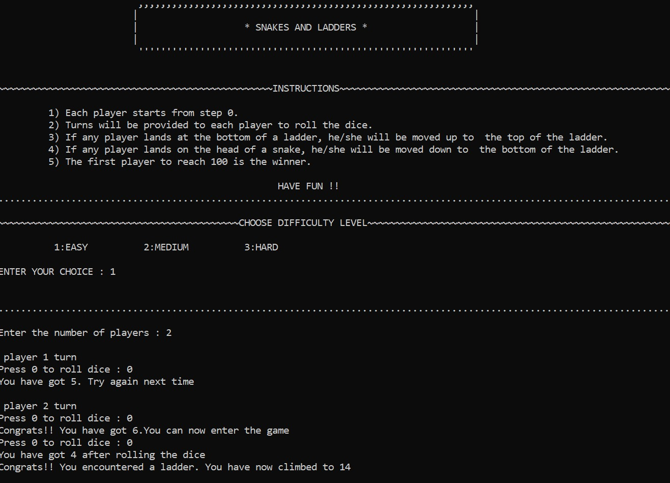

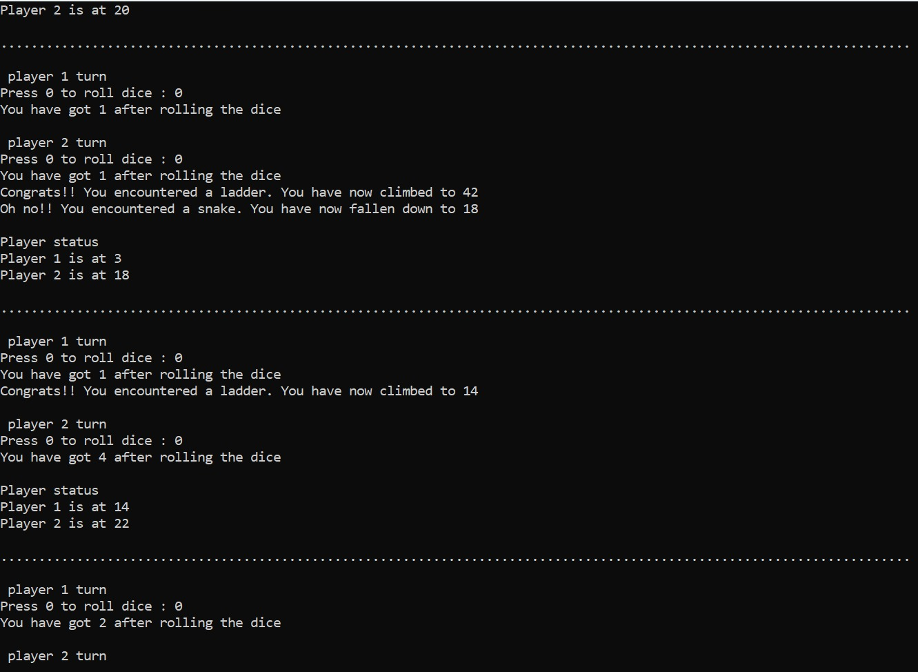
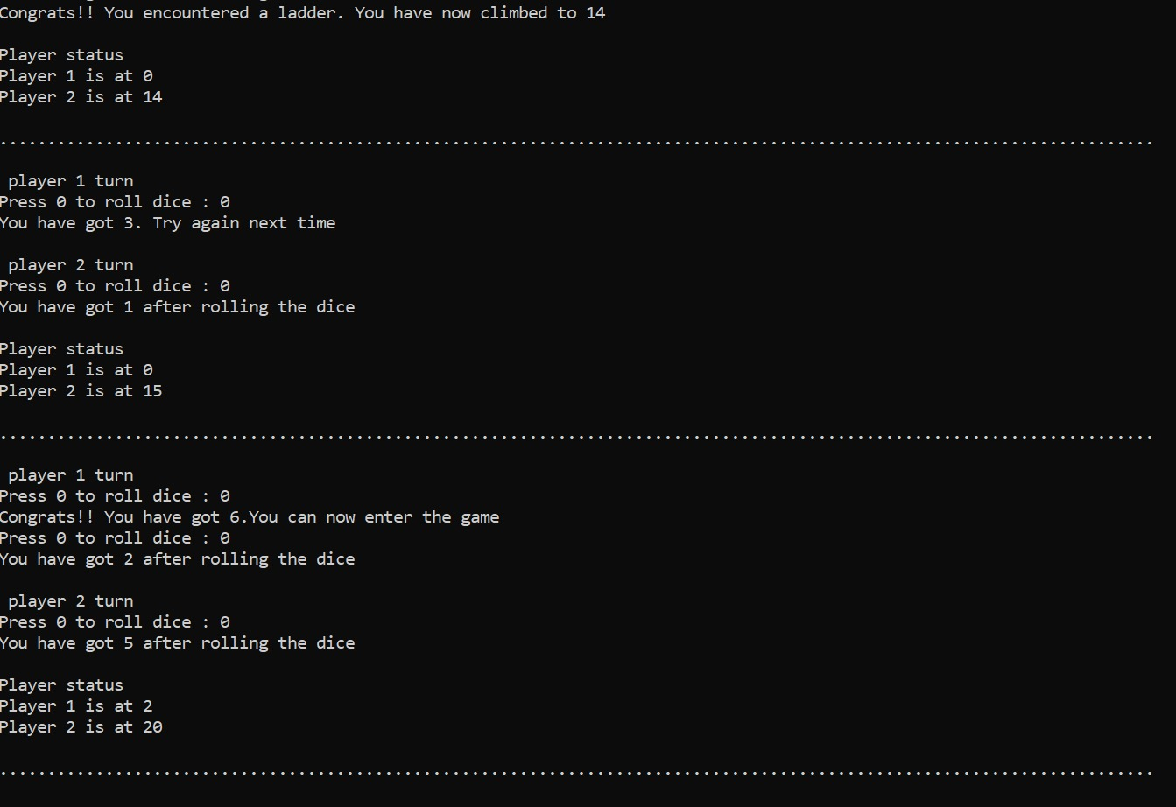

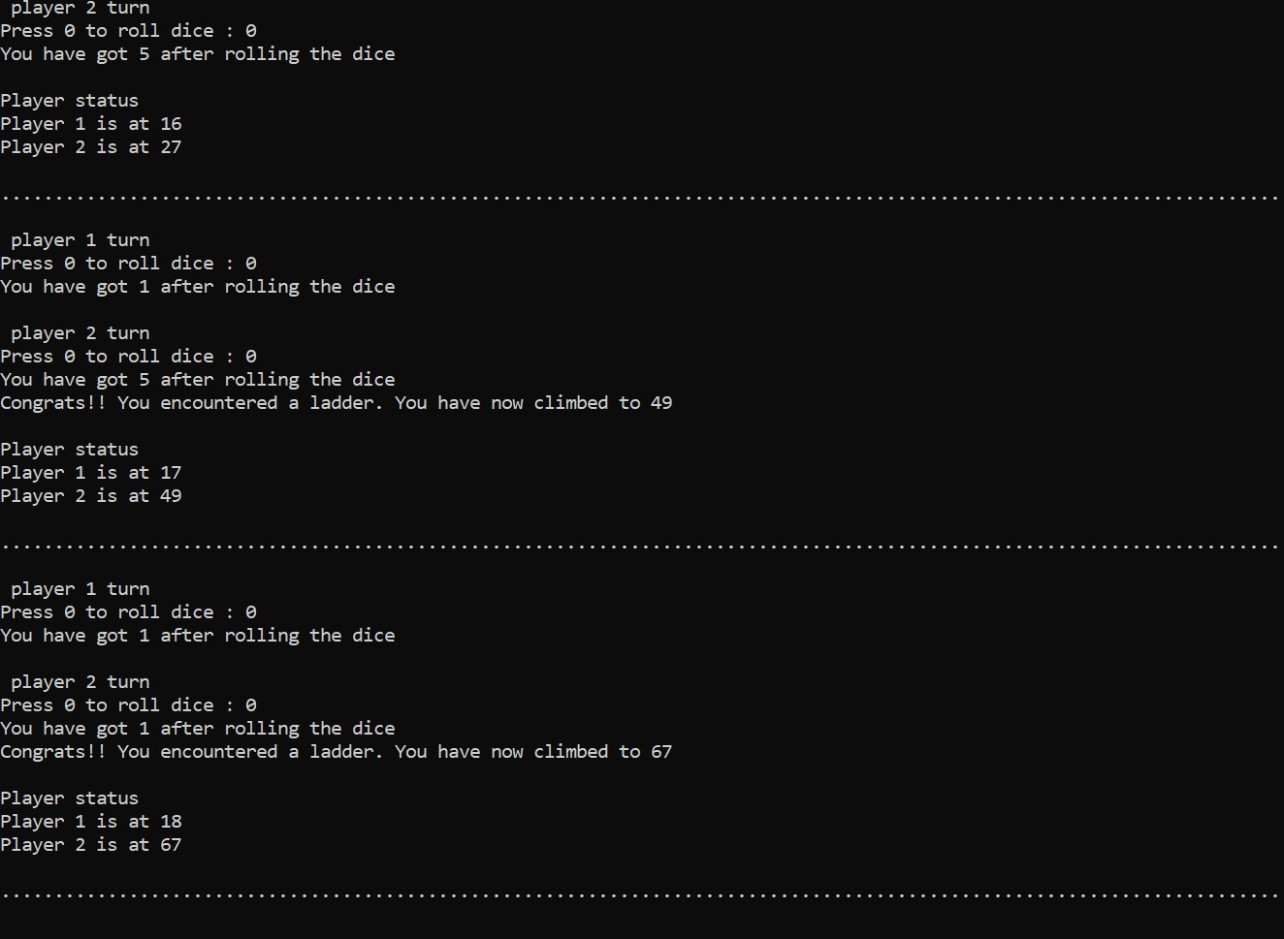

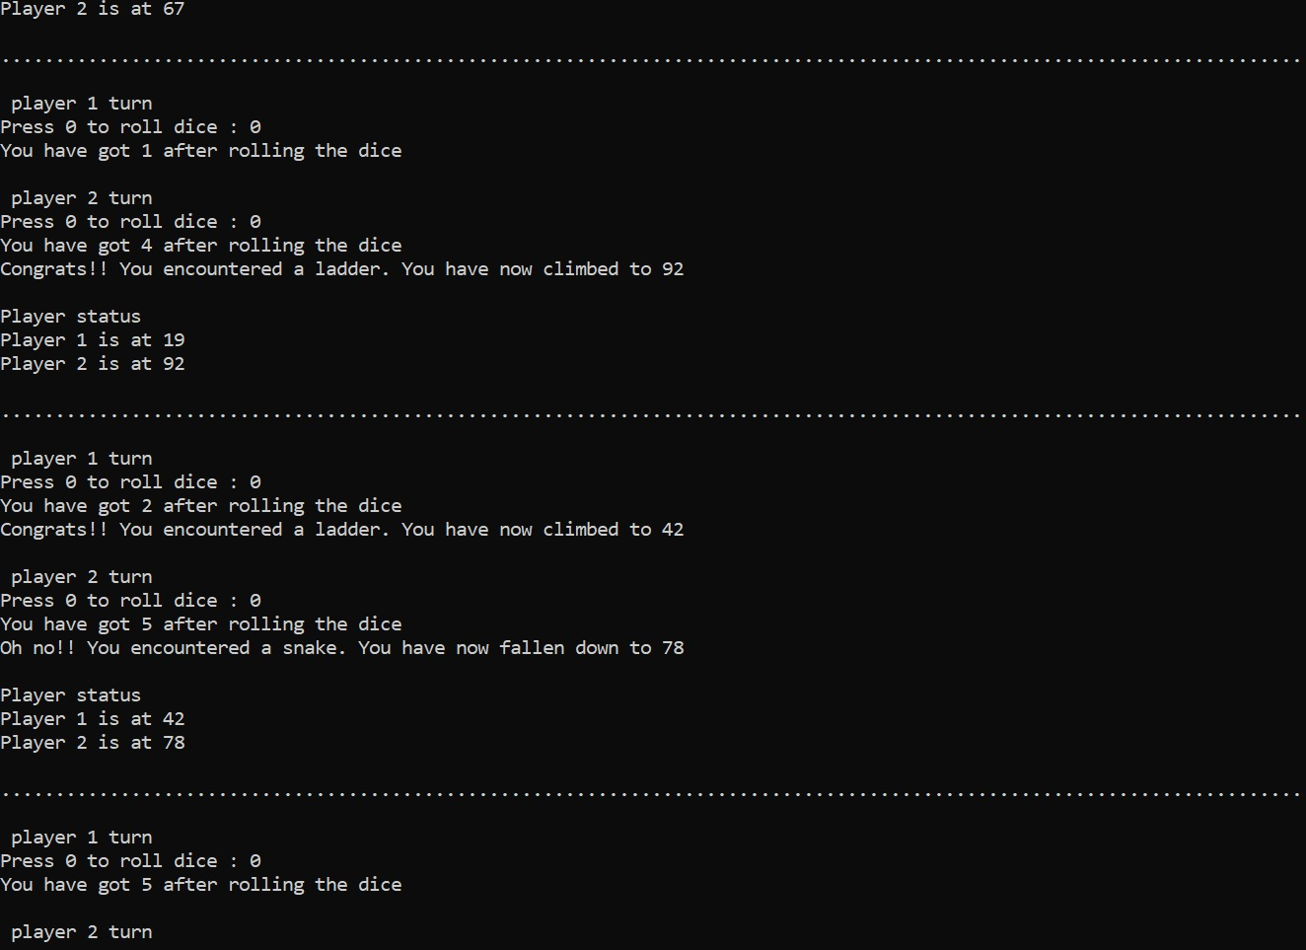

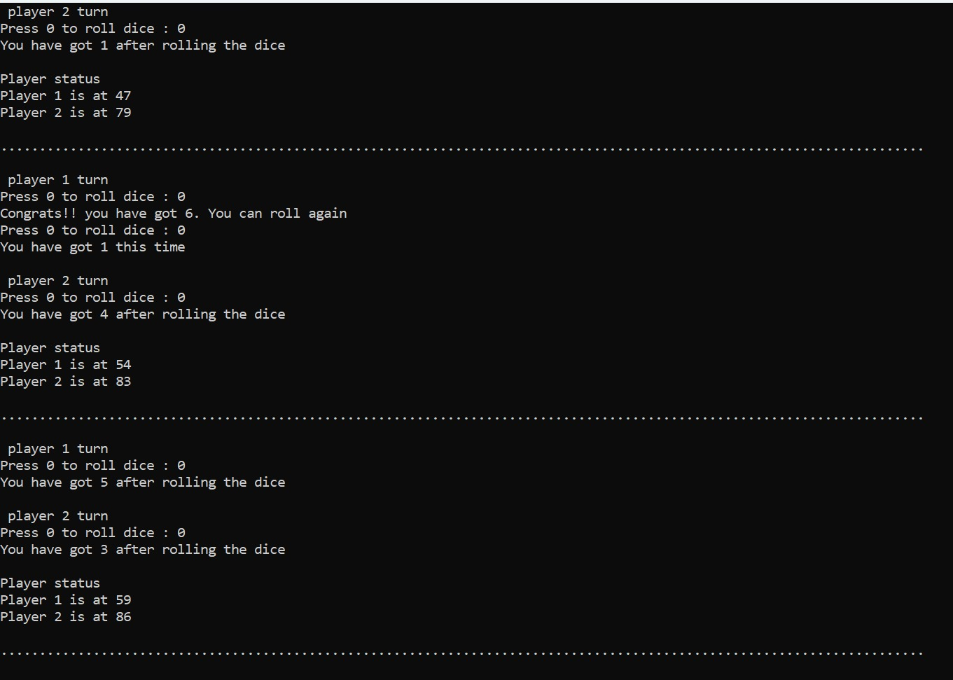
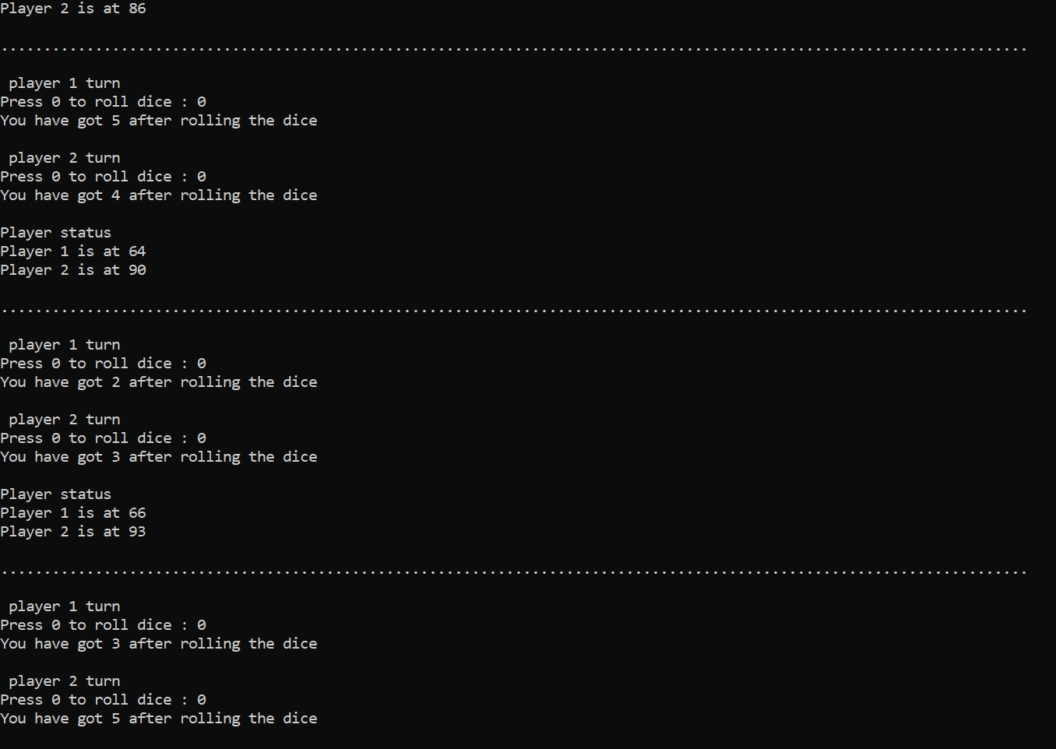

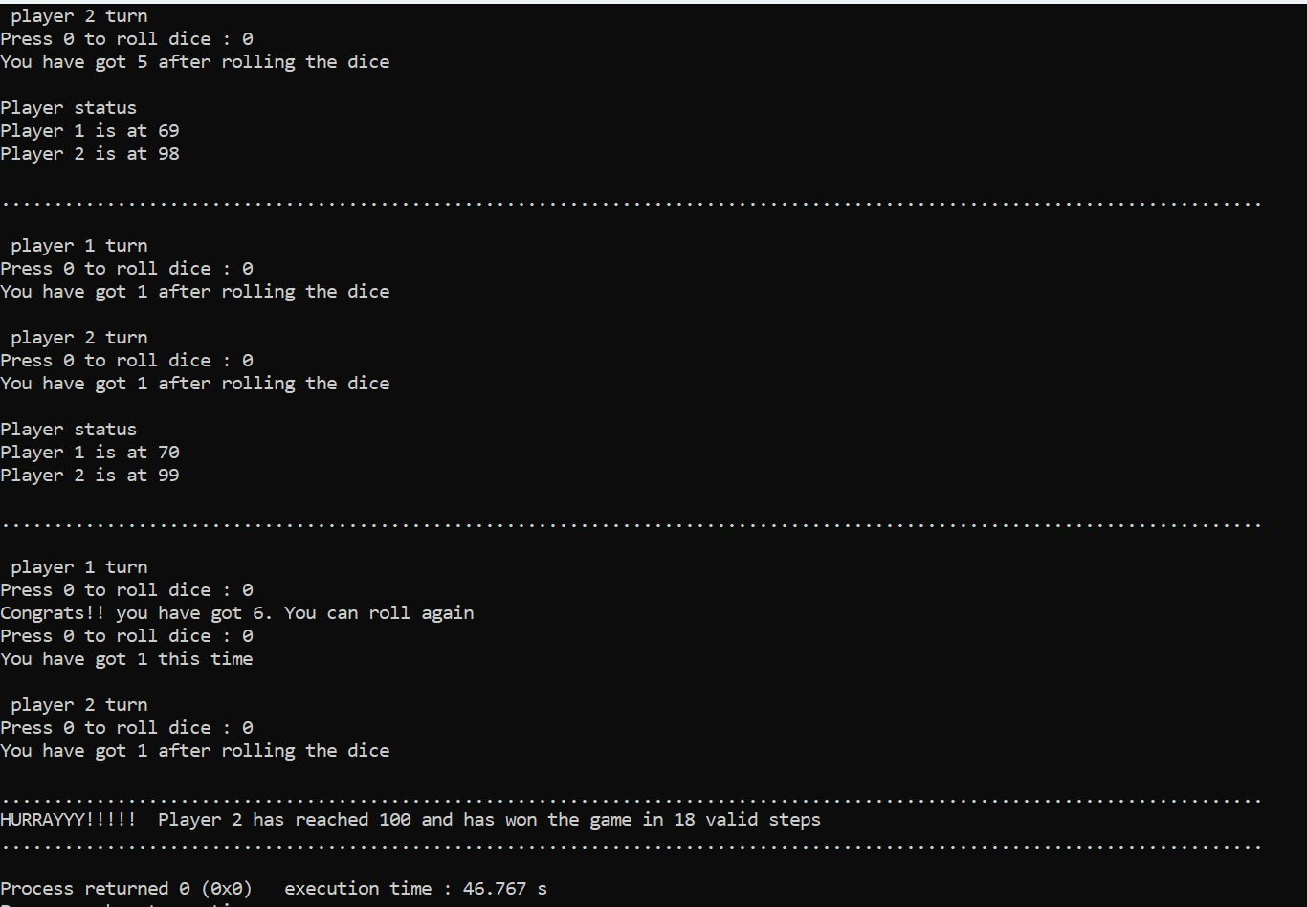

CONCLUSION

In conclusion, the Snake and Ladder game created using C language is a fun and interactive project that not only helped to enhance our programming skills but also provided an enjoyable gaming experience. We were able to implement various programming concepts like loops, conditional statements, functions, and arrays to develop a functional game with proper game rules and user interface.

Additionally, the project allowed us to showcase our problem-solving skills, creativity, and teamwork. Overall, the Snake and Ladder game created using C language has been an excellent learning experience that has taught us how to use programming to create engaging and interactive games.

We hope that this game will bring joy and entertainment to everyone who plays it.

